**IMPLEMENTATION DEPLOYMENT**

An implementation plan presents the Conduct of Functional Requirement Analysis, Conduct of Program Design, Conduct of Interface Design, and the Deployment Diagram.

**4.1 Conduct of Functional Requirement Analysis**

The study is consists of two modules namely; User Module and Admin Module. The user module can access the system, manages user account, manages his/her booking, view updates and can manipulate the payments. The admin module can access the system, manages both admin and user accounts, manages booking, manages updates, view reports and can print all the reports.

**4.2 Conduct of Program Design**

The use of Developmental project design was observed using the waterfall approach. In this project, the designer planned, analysed, designed and implemented the system. This was considered appropriate because the process was done step by step started from planning, analysis, design then implementation. The output is the system itself we called it grab a van system.

**4.3 Conduct of Interface Design**

The Results and Discussion of the parameters in conformity to the stipulated scope and objectives regarding the Grab a Van System. See figures as follows

1. Manages account   
   1.1 Accesses the system

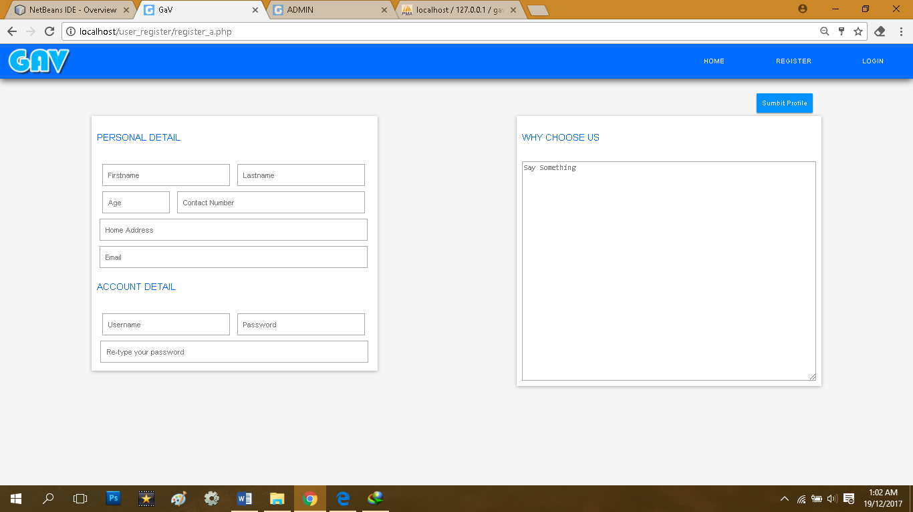

Figure 14. User Register

Figure 14 shows the interface of the user register account, where the user inputs all the important details such as the first name, last name, age, contact number, home address, email, username, and the password in order to log on the system.

.

1.2 User Log in

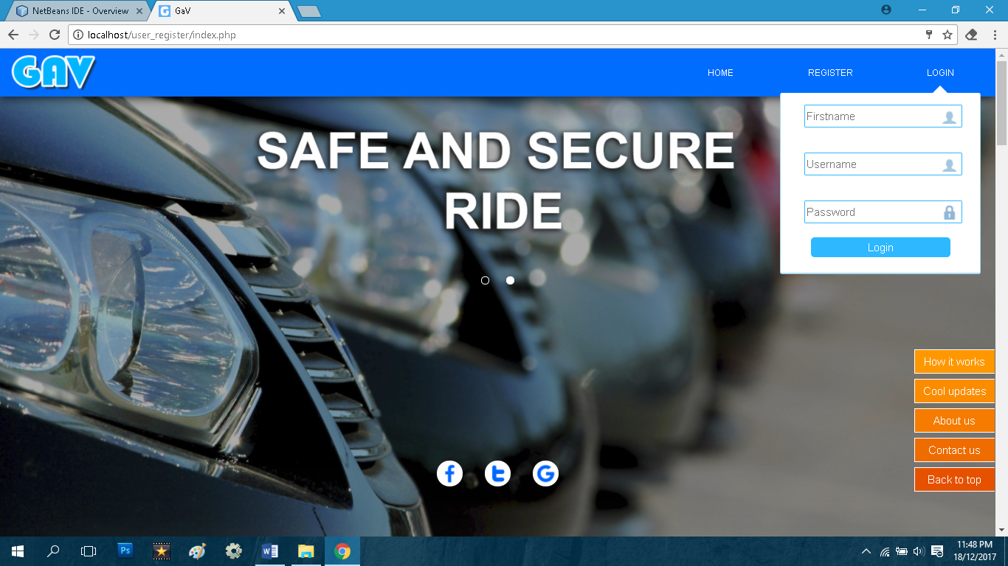

Figure 15. User Login Page

Figure 15 shows the interface of the Login homepage where the user logs on the system by simply inputting the correct first name, username, and password of the user. The inputted first name, user name and password must be registered account so that the inputted first name, user name and password would not be invalid and the user can access the system, if the user account has been freeze a message will be displayed that their account is freeze, Scroll down to view other information about the system like updates and the steps of how to book.

1.3 Manages Account

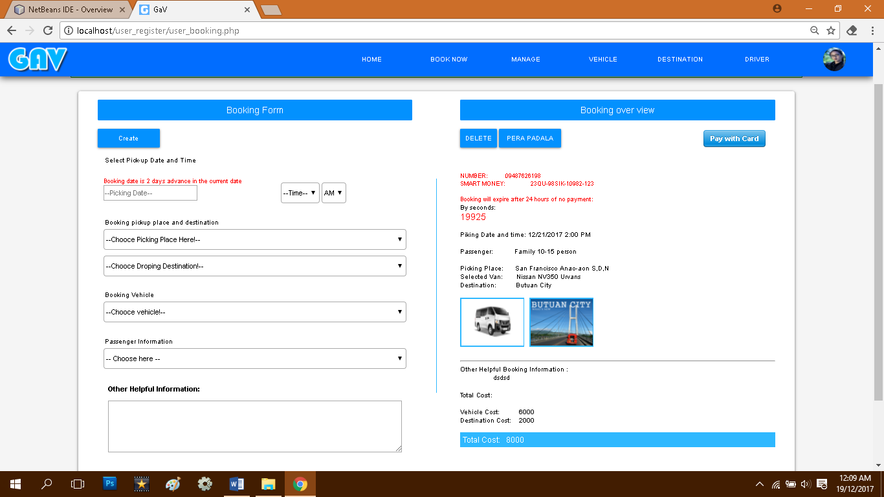

Figure 16. Manages Booking

Figure 16 shows the interface of the user creates booking, where the user chooses pick-up dates, pick-up place, vehicle, and dropping destination. This figure, the user can view all the details of the reservation. In this figure also the user can cancel or delete his/her booking by clicking the delete button and if the user can’t pay the reservation within 24 hours, the booking will automatically expired which means the reservation will be cancelled.

1.4 View Reports

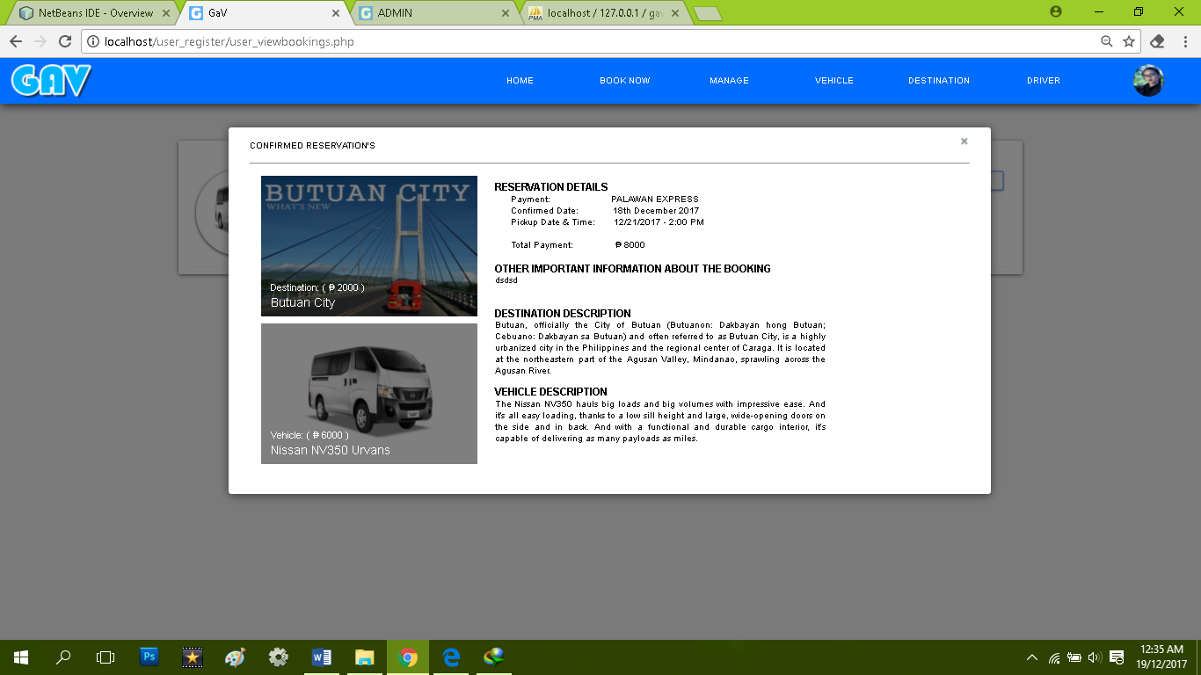

Figure 17. View Reports

Figure 17 shows the interface of the user booking. In this figure the user also can view the availability of the vehicles, destination and can view the details reservation, the description of the place and the vehicles description.

1.5 Manages Payments

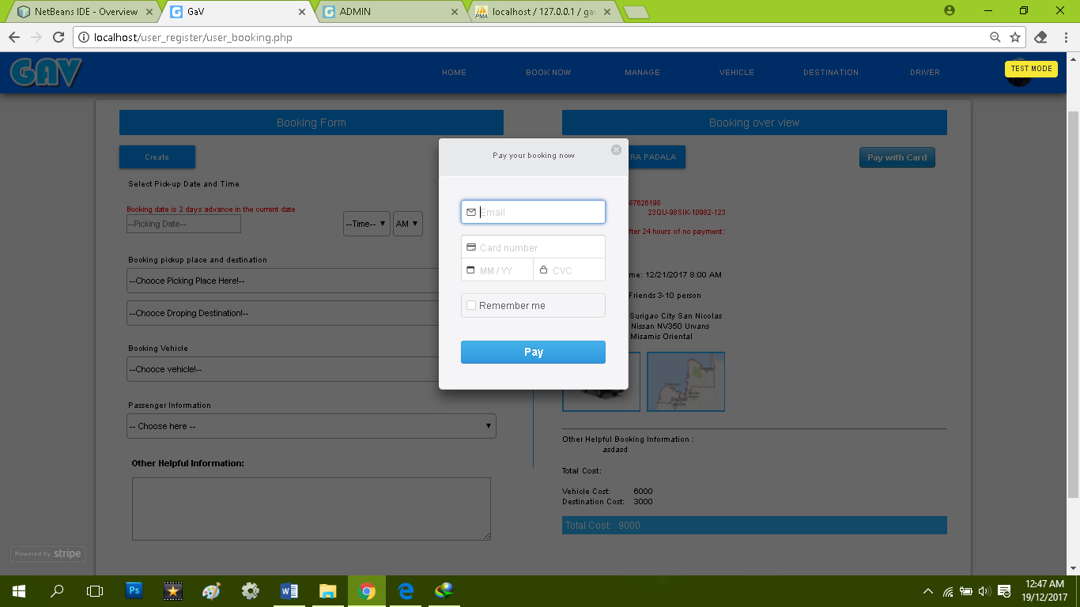

Figure 18. Manages Payment

Figure 18 shows the interface of the payments method, where the user chooses how he/she paid his/her booking via online payment method by using Visa or via Cebuana, Smart Padala or Palawan Express.

1.6 Generate Report  
1.6.1 Booking Overview

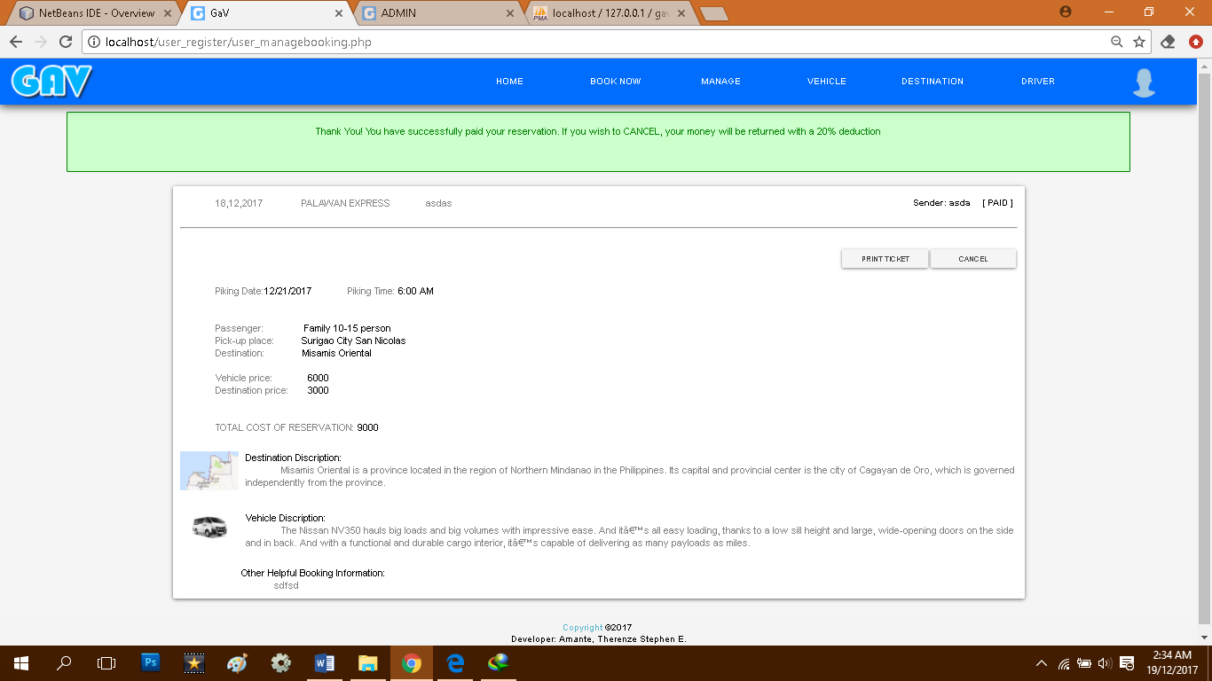

Figure 19. Booking Overview

Figure 19 shows the interface of the user’s booking overview, where the user can print the ticket reservation. The user can also cancel its booking by clicking the cancel button where the payments will be deducted 20 percent if the user cancelled its booking.

1.6.2 Reservation Ticket

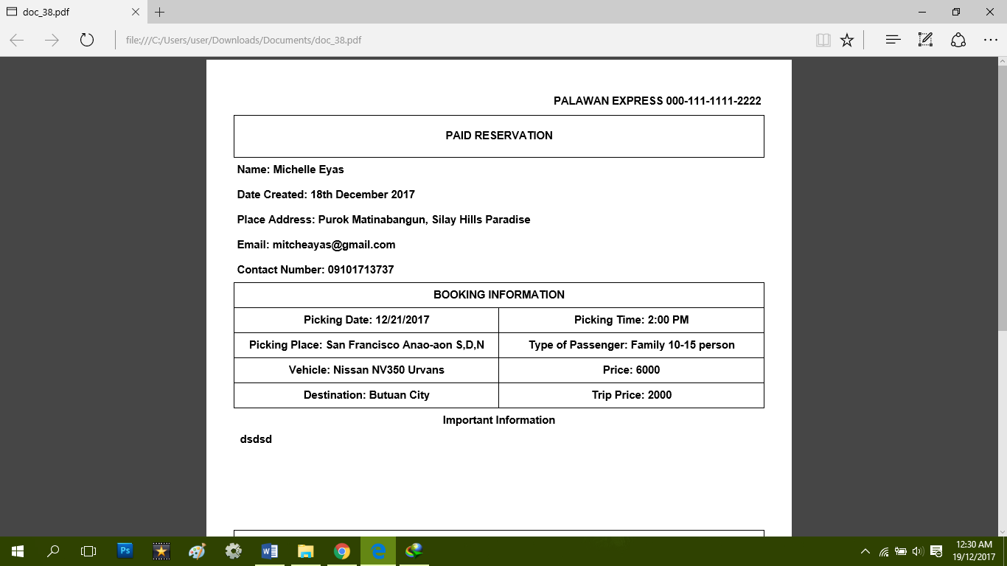

Figure 20. Booking Ticket

Figure 20 shows the interface of the Booking ticket. It displays the information of the bookers name, date of the booking of when it is created, address of the booker, email of the booker and contact number of the booker. In this figure the booker can also view the booking information such as the pick-up date, pick-up place, pick-up time, and etc.. in order to notify that the user has been booked already and to prove that the user paid the reservation already.

1. Admin Module

2.1 Accesses the system

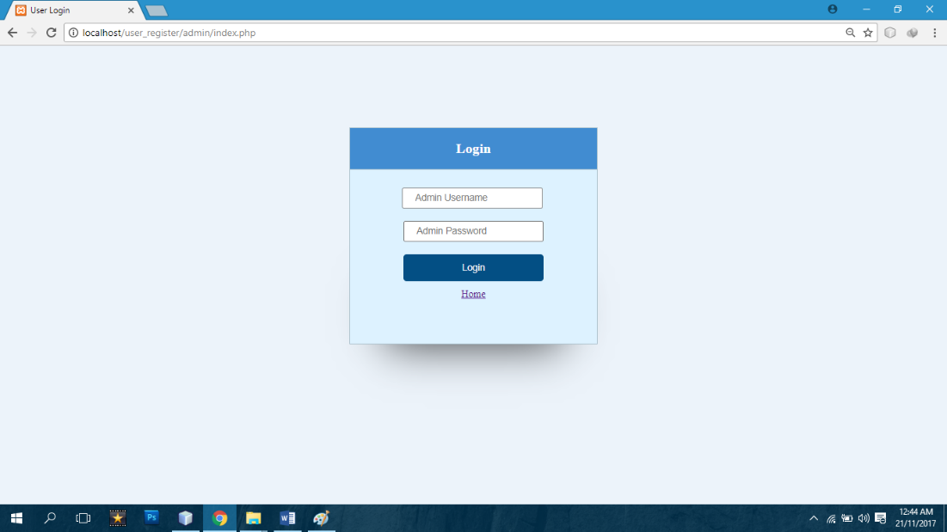  
  
Figure 21. Admin Login Page

Figure 21 shows the interface of the Login where Admin logs on the system by simply inputting the correct username and password of the admin. The inputted username and password must be a registered account so that the inputted username and password would not be invalid or not registered.

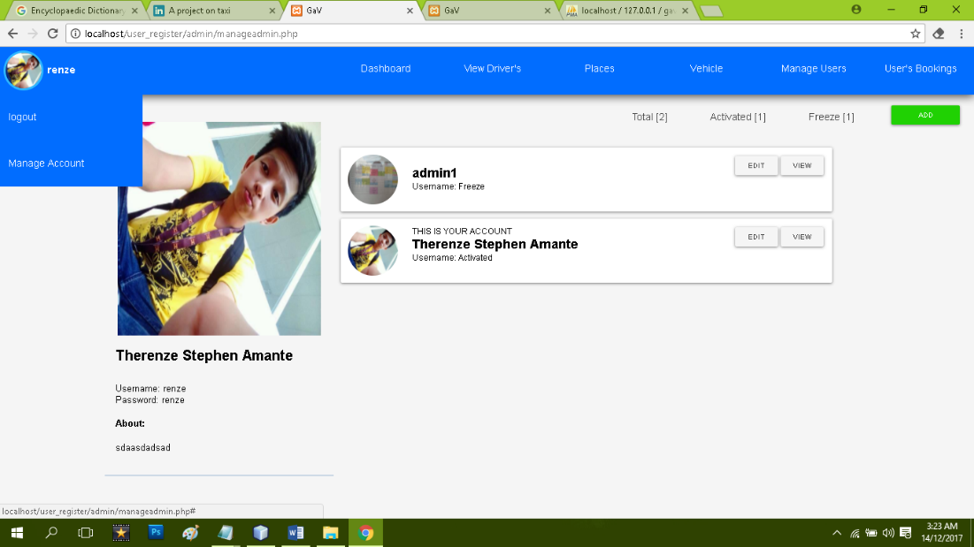2.2 Manages Account

Figure 22. Manages Account

Figure 22 shows the interface of the Admin manages account. In this figure, only the admin can manipulate in deleting or to freeze account. The admin also can add, update, and freeze accounts

2.3 Manages Booking

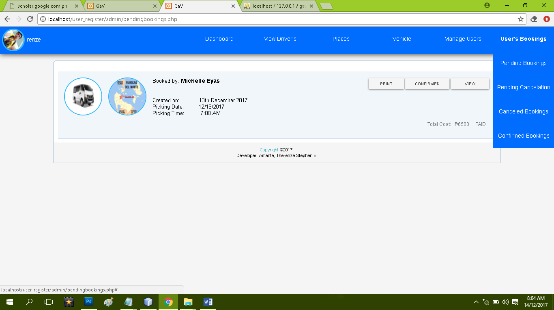

Figure 23. Manages Booking

Figure 23 shows the interface of User’s Bookings, Pending Bookings, Cancelled Bookings, and Confirmed Bookings. In this figure as shown in figure 14.2, the admin can confirm the pending reservation, and can cancel reservation that has been booked. In this figure also, the admin can view the exact reservation of the user, and can print ticket booking.

2.4 Manages Updates

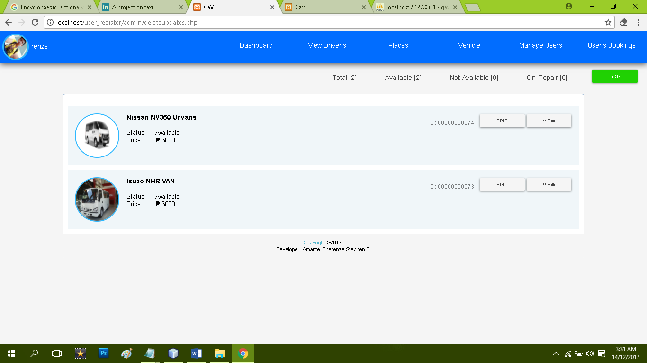

Figure 24.Update vehicle

Figure 24 shows the interface of all the vehicles. In this figure, the admin can add a new vehicle and can also edit whether the vehicle is available, not-available or on-repair. In this figure also, the admin can view the total available vehicle, not-available and on-repair and can edit the information of the vehicle.

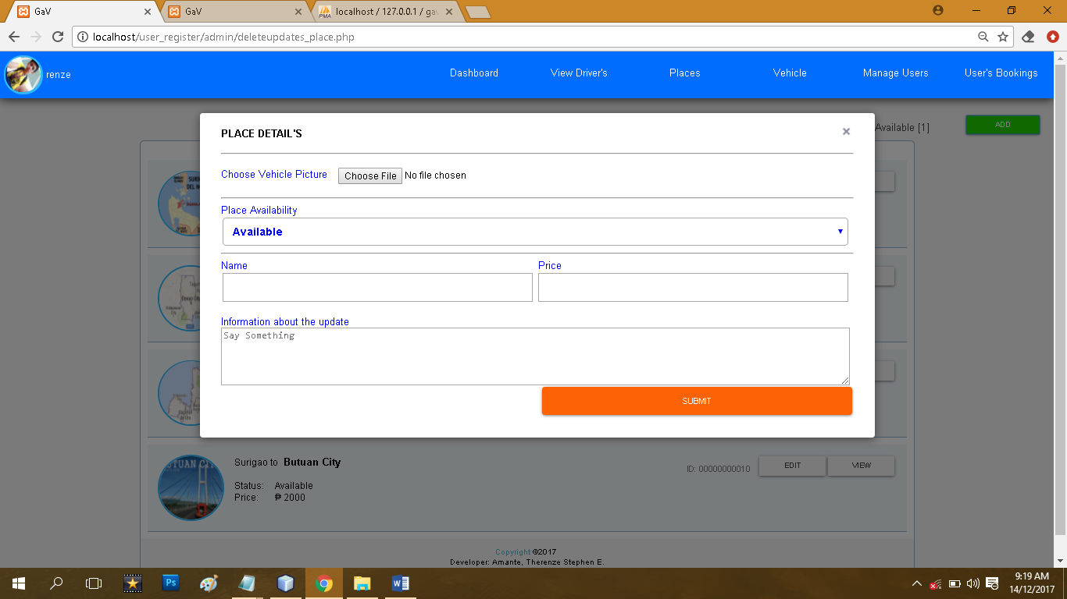

Figure 25.Updates destination

Figure 25 shows the interface of all the destination. In this figure, the admin can add a new destination and can also edit whether the places is available or not-available. In this figure also, the admin can view the total available destination and not-available and can edit the information of the place.

.

2.5 View Reports

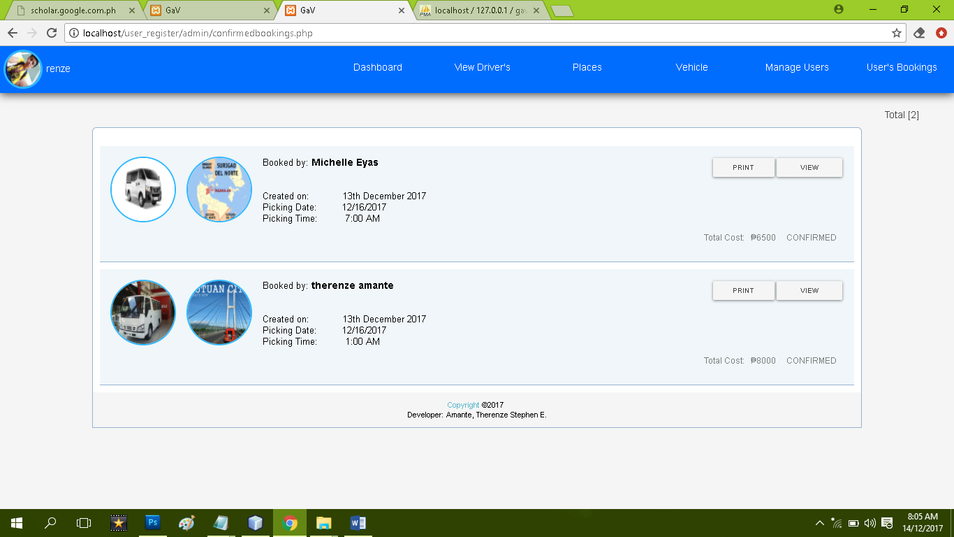

Figure 26. View all reservations

Figure 26 shows the interface of all the details of the reservation. In this figure, the admin can view all the important details of the reservation, the total bookings, and the admin can also print the ticket of the reservation.

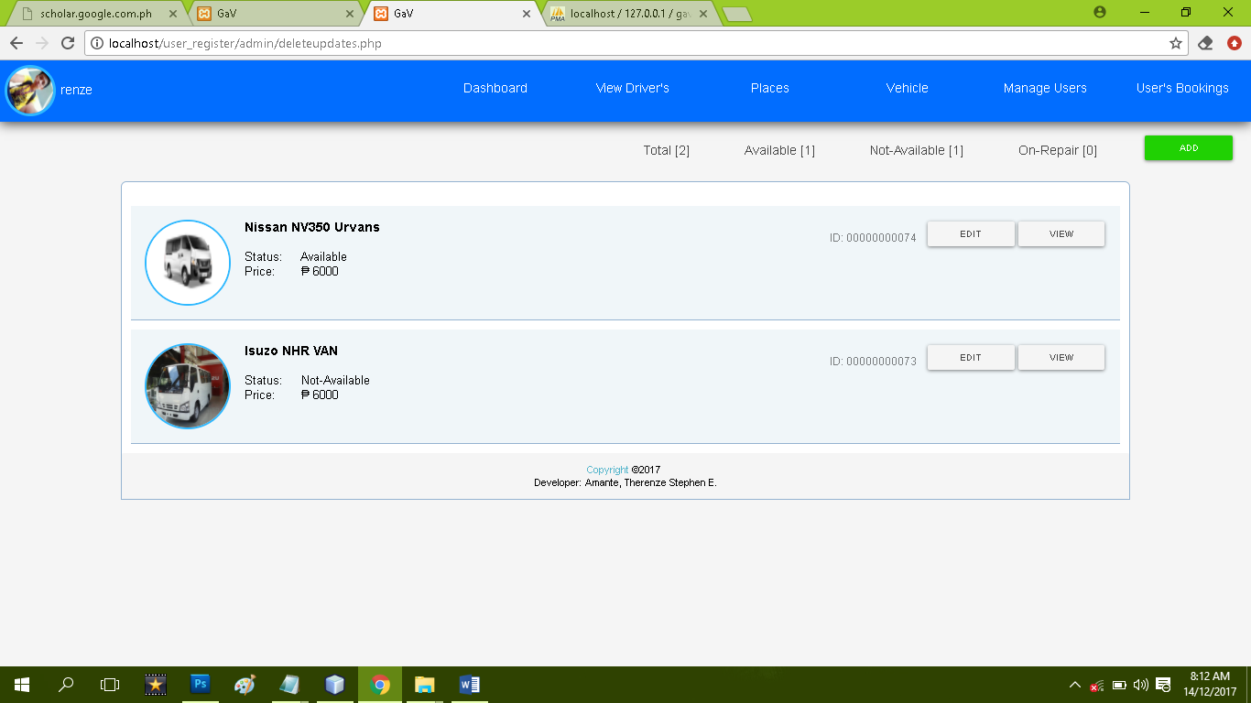

41

Figure 27. View available/non-available vehicle

Figure 27 shows the interface of the availability of the vehicles where the admin can view and edit the availability of the vehicle.

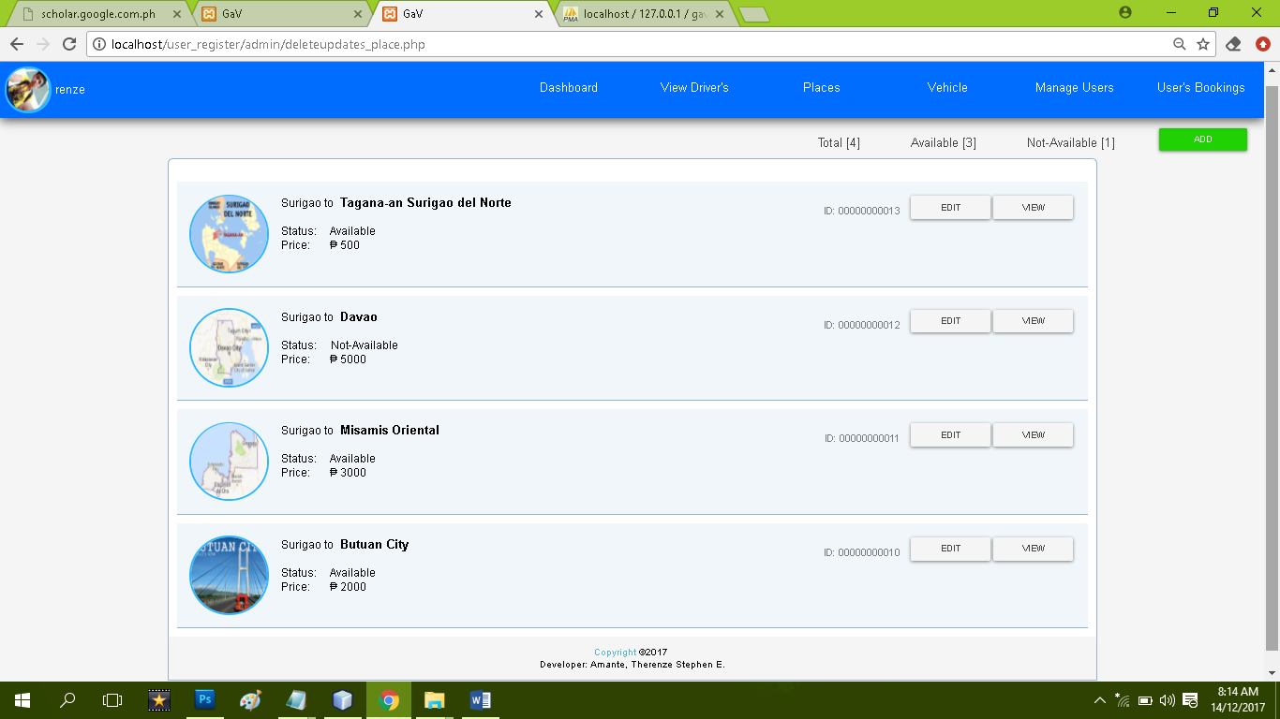

Figure 28. View available/non-available place

Figure 28 shows the interface of the availability of the place where the admin can view and edit the availability of the place.

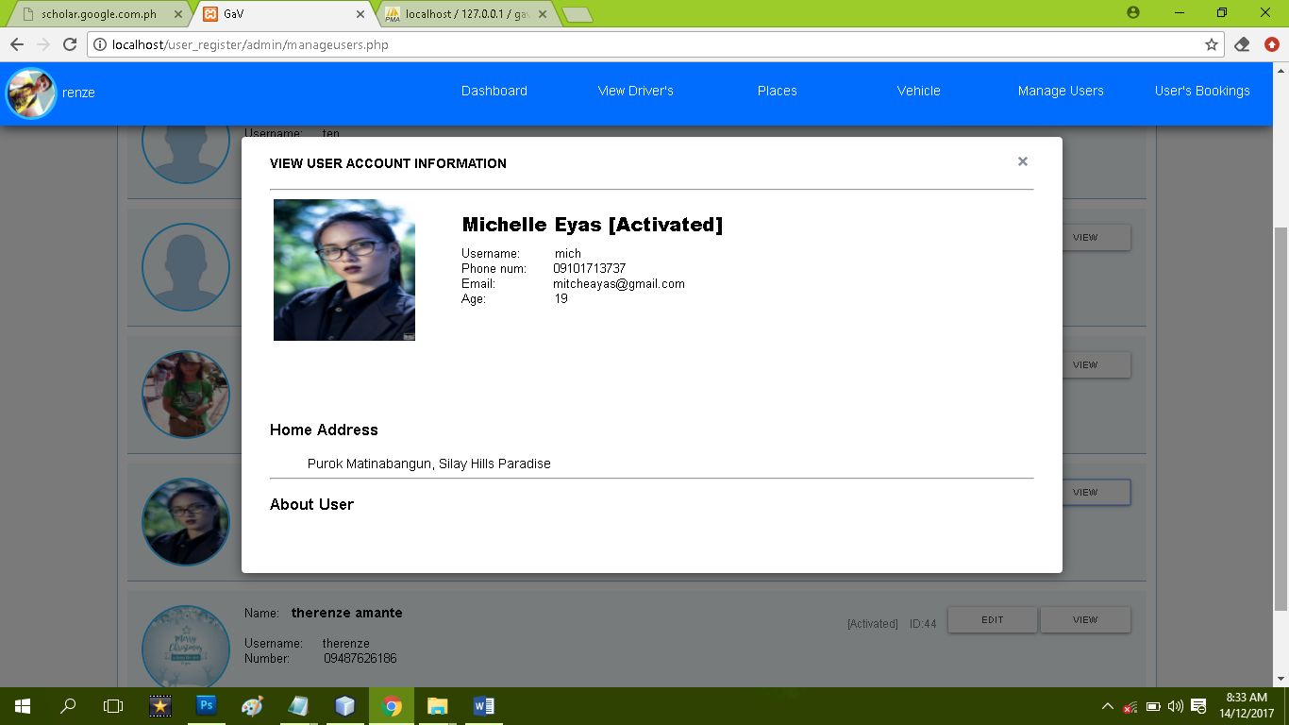

Figure 29. View Account details

Figure 29 shows the interface of the user info such as Username, Phone number, Email, Age, Home address, and about the user.

2.6 Generate Reports

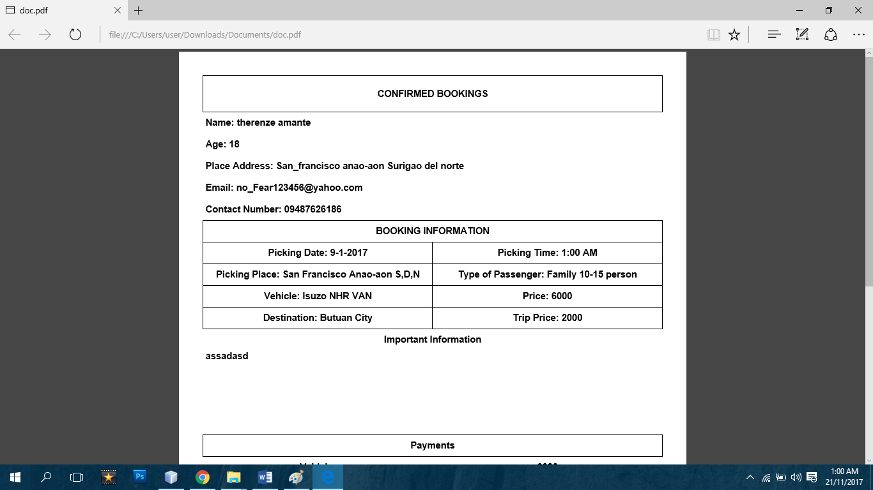

Figure 30. Print User reservation.

Figure 30 shows the interface of the important information to be print, like the Name, age, place Address, Email, Contact number and also the booking information where we can see the exact picking-up date, pick-up time, pick-up place, type of vehicle, type of passenger, destination, payments to be paid. In this figure, the admin can print the total reservations and all total payments.

**4.4 Deployment Diagram**

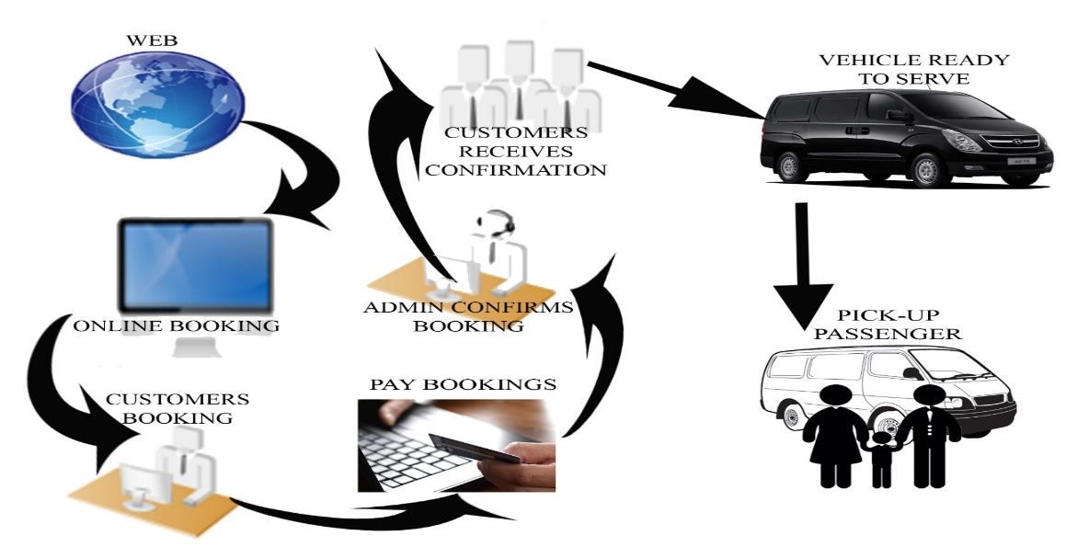 The implementation of the designed system which is Grab a Van System is for Lime & Basil Nail Spa, see figure 14.11. It displays the deployment of the system.

Figure 31 Deployment Diagram

The system has two users, specifically; the Admin and the Client. In our Deployment diagram, as we can see in figure 31, the first picture represents the internet. Grab a van is an online booking system that is why we need an internet in order to book. The second picture is an online booking, where we can book/ reserve. The third picture shows that the customer or the user has been booking and in the fourth picture, the user is paying his/her reservation.

In order to notify that the user get the confirmation from the admin, the fifth picture shows that the admin confirmed the user’s booking and in the sixth picture the customer or the user has now receiving confirmation from the admin and in the seventh and eighth picture, the vehicle is now ready to serve and is waiting for the passengers where, and when, to pick and the time of the pick-up.